Sara Gold Reports
WPLC Board Meeting, January 22, 2013

6a) Content Reserve Update
OverDrive reports they should have a date for the upgrade to be implemented by the end of this week.
6b) Selection Committee Update
2012 Collection Summary:
29,642 titles purchased (includes Holiday Bonus titles)
5,126 Audiobooks
24,516 eBooks

Featured Holiday Titles:
Beautiful Creatures | Kami Garcia/Margaret Stohl
Breathless | Jessica Warman
Cloud Atlas | David Mitchell
Dark Places | Gillian Flynn
End of Your Life Book Club | Will Schwalbe
Gone Girl | Gillian Flynn
The Round House | Louise Erdrich
The Racketeer | John Grisham
Thomas Jefferson | Jon Meacham

Results of OverDrive Holiday Promotion:
WPLC received 2532 titles worth $37,464.78 in bonus content for our holiday spending. Spreadsheet of titles is available.

Circulation Stats
In case you hadn’t heard, the Wisconsin Digital Library was the number 1 circulating OverDrive collection in the country from December 24-December 27! See the chart below; OverDrive couldn’t provide the other libraries circulation numbers without their permission, but some of the other top libraries include Phoenix, Maryland, King County, and Toronto.
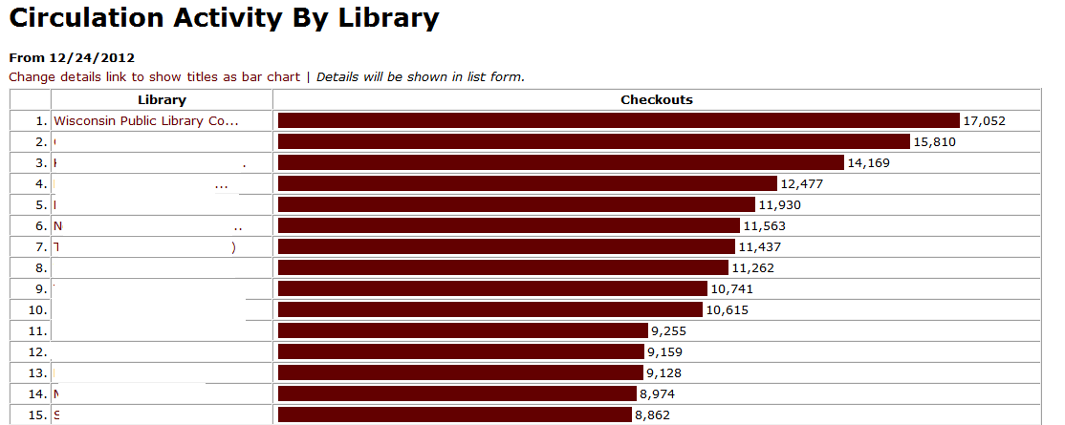
Looking at the WPLC collection in more detail, December 26 saw the highest circulation that we have seen EVER, of 6,588 checkouts: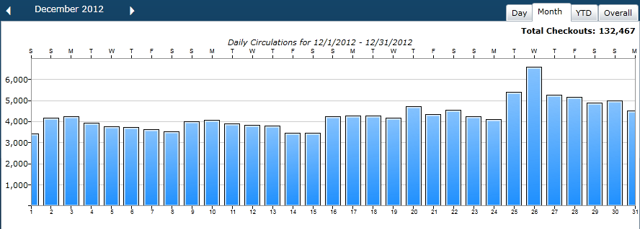

7c) ReadersFirst
ReadersFirst is a national movement to improve e-book access and services for public library users. The coalition had its inaugural meeting at the 2012 ALA Conference and created a list of content access requirements for publishers and distributors of digital materials, which focus on four basic areas:
- Search and browse a single comprehensive catalog with all of a library’s offerings at once, including all e-books, physical collections, programs, blogs, and donor opportunities. Currently, content providers often only allow searches within the products they sell, depriving users of the comprehensive library experience.
- Place holds, check-out items, view availability, manage fines and receive communications within individual library catalogs or in the venue the library believes will serve them best, without having to visit separate websites (libraries, not distributers, should be enabled to manage all interactions with users).
- Seamlessly enjoy a variety of e-content. To do this, libraries must be able to choose content, devices and apps from any provider or from multiple providers, without bundling that limits a library’s ability to serve content they purchase on platforms of their choice.
- Download e-books that are compatible with all readers, from the Kindle to the Nook to the iPad and so on.
Organizations are able to join the coalition by self-subscribing via the ReadersFirst website. Libraries are asked to read and sign the ReadersFirst Content Access Requirements Agreement to participate in ReadersFirst. The libraries who signed this agreement are committed to holding content providers to this standard, and will prioritize these requirements when acquiring e-books and other e-content.
ReadersFirst Content Access Requirements – Draft
There are currently 226 libraries, library systems, consortia and library service providers as recognized members. Organizations are able to join the coalition by self-subscribing via the ReadersFirst website. Madison Public and Milwaukee Public Libraries are the two WI organizations to join ReadersFirst.
10 major publishers and ILS vendors are meeting with members of ReadersFirst at ALA Midwinter in Seattle. See here for details. Participation of libraries is by invitation only and extended to members of ReadersFirst.

