Wisconsin Author Project Social Media Posts

For Facebook
Attention [community] writers! Do you have a book that you’d like to publish or that you’d like to help readers discover? The [library name] wants to help you get the recognition you deserve for it! Submit your book to the WIsconsin Author Project for a chance to win $1000 and a whole bunch of other prizes, including a review in Library Journal! Read more or submit your eligible book by June 30th at http://bit.ly/wiauthorproject.

The [library name] wants to help you get the recognition you deserve for your book in the Wisconsin Author Project. If you have an adult or young adult work of fiction that you’d like to bring readers to, and maybe even win $1000 for, check out the eligibility requirements and submit your work by June 30th at http://bit.ly/wiauthorproject.

[Find more free images like these at Unsplash!]
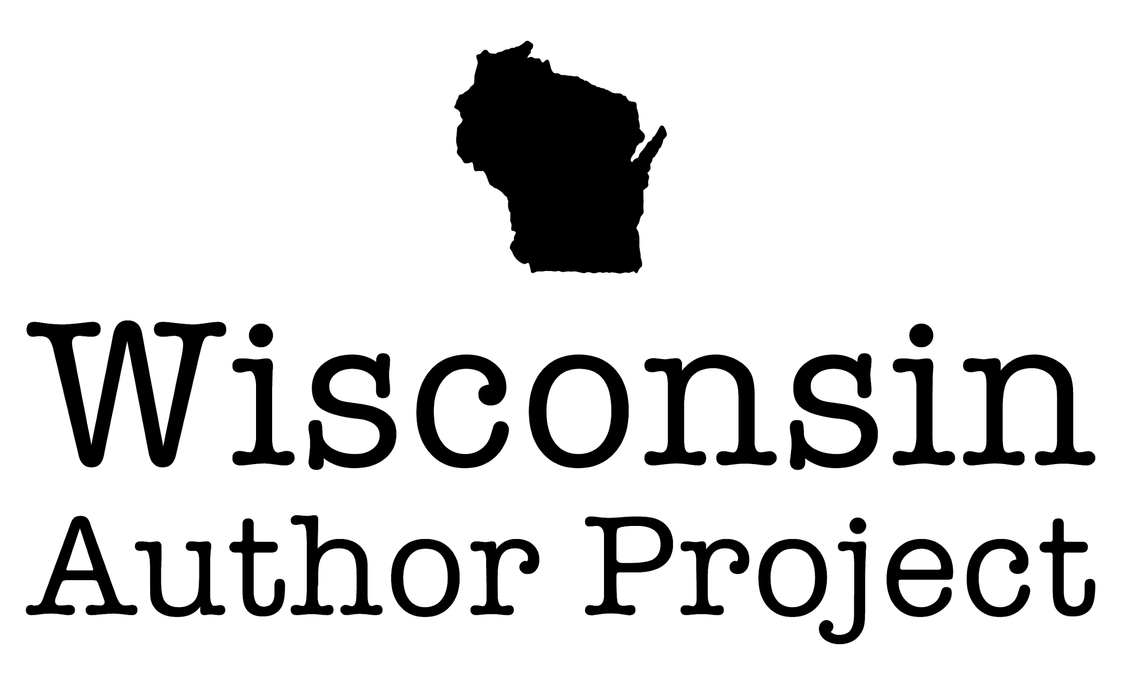
The [library name] proudly brings you the Wisconsin Author Project! This project helps local authors get the recognition they deserve for their work One winner gets $1000 and a review in Library Journal plus a bunch of other prizes! Dust off that book you tucked away - or send the brand new one that you just finished - and help readers discover you! Submit your book by June 30th at http://bit.ly/wiauthorproject/.

[Find alternate Wisconsin Author Project logos or images to use here.]

For Twitter
Attention #wisconsinwriters! Do you have a book to publish or to help readers discover? Would you like to win $1000? The library also wants that! Submit your book to the Wisconsin Author Contest by June 30th at http://bit.ly/wiauthorproject. #wiwriters #wiauthors

The library wants to help #wisconsinwriters find readers for their books! Enter your book to the Wisconsin Author Contest by June 30th at http://bit.ly/wiauthorproject for a chance to win $1000 and find your fans. #wiwriters #wiauthors

