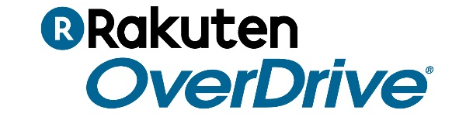
FOR IMMEDIATE RELEASE
Wisconsin’s Digital Library celebrates 4.25 million digital checkouts in 2017
Readers borrow record number of eBooks & audiobooks
MILWAUKEE — Feb. 22, 2018 — The Wisconsin Public Library Consortium announced today that readers borrowed over 4.25 million digital books through its OverDrive-powered Wisconsin’s Digital Library in 2017, a new record. With an ever-expanding digital collection of eBooks and audiobooks, Wisconsin’s Digital Library experienced year-over-year growth of 6.9 percent from 2016 as they joined the "Million Checkout Club" of 58 libraries worldwide.
Wisconsin Public Library Consortium launched Wisconsin’s Digital Library in 2005, providing readers 24/7 access to eBooks and audiobooks. Reader interest and usage has grown every year since.
The top 5 titles readers borrowed through Wisconsin Public Library Consortium's OverDrive-powered digital collection in 2017 were:
1. The Girl on the Train, Paula Hawkins
2. The Whistler, John Grisham
3. Turbo Twenty-Three, Janet Evanovich
4. Small Great Things, Jodi Picoult
5. Truly Madly Guilty, Liane Moriarty
Readers just need a valid library card to access digital books from Wisconsin’s Digital Library. Readers may use any major device, including Apple^{(R)}, Android™, Chromebook™ and Kindle^{(R)} (U.S. only). Visit https://wplc.overdrive.com or download the Libby app to get started and borrow eBooks and audiobooks anytime, anywhere.
About OverDrive and Libby
OverDrive is the leading digital reading platform for libraries and schools worldwide. Libby is the highly rated "one-tap reading app" for libraries. We are dedicated to “a world enlightened by reading” by delivering the industry’s largest catalog of eBooks, audiobooks and other digital media to a growing network of 40,000 libraries and schools in 70 countries. Founded in 1986, OverDrive is based in Cleveland, Ohio USA. www.overdrive.com - meet.libbyapp.com
Contact:
Wisconsin Public Library Consortium
www.wplc.info
Contact:
David Burleigh
Director of Brand Marketing & Communication
OverDrive
dburleigh@overdrive.com
###

